

IMAGE BASED ANIMAL TYPE CLASSIFICATION FOR CATTLE AND BUFFALOES
A PROJECT REPORT

Submitted by
HARSHITHA K J - 20221CDV0026
SUSHMITHA S - 20221CDV0038
GREESHMA - 20221CDV0040

Under the guidance of,
Mr. SAHABZADA BETAB BADAR

BACHELOR OF TECHNOLOGY

IN

COMPUTER SCIENCE AND TECHNOLOGY (DevOps)

PRESIDENCY UNIVERSITY
BENGALURU
APRIL 2026



PRESIDENCY SCHOOL OF COMPUTER SCIENCE AND ENGINEERING
BONAFIDE CERTIFICATE

Certified that this report “Image based Animal Type Classification for cattle and buffaloes” is a bonafide work of “Harshitha K J (20221CDV0026), Sushmitha S (20221CDV0038), Greeshma (20221CDV0040)” who have successfully carried out the project work and submitted the report for partial fulfilment of the requirements for the award of the degree of BACHELOR OF TECHNOLOGY in COMPUTER SCIENCE AND TECHNOLOGY (DEVOPS) during 2025-26.

Mr. Sahabzada Betab Badar  Assistant Professor  Project Guide  PSCS (Spl. Division)  Presidency University | Dr. H M Manjula  Associate Professor  Program Project Coordinator  PSCS (Spl. Division)  Presidency University | Dr. Sampath A K  Professor  School Project Coordinator  PSCS (Spl. Division)  Presidency University

Dr. S Pravinth Raja  Professor & Head of the Department  PSCS (Spl. Division)  Presidency University  Name and Signature of the Examiners | Dr. Shakkeera L  Associate Dean  PSCS (Spl. Division)  Presidency University
Sl. No | Name of the Examiner | Signature | Date



PRESIDENCY UNIVERSITY

PRESIDENCY SCHOOL OF COMPUTER SCIENCE AND ENGINEERING
DECLARATION

We the students of final year B.Tech in COMPUTER SCIENCE AND TECHNOLOGY, DEVOPS at Presidency University, Bengaluru, named Harshitha K J, Sushmitha S, Greeshma, hereby declare that the project work titled “Image based Animal Type Classification for cattle and buffaloes” has been independently carried out by us and submitted in partial fulfilment for the award of the degree of B.Tech in COMPUTER SCIENCE AND TECHNOLOGY, DEVOPS during the academic year of 2025-26. Further, the matter embodied in the project has not been submitted previously by anybody for the award of any Degree or Diploma to any other institution.

Harshitha K J USN:20221CDV0026
Sushmitha S USN:20221CDV0038
Greeshma USN:20221CDV0040

PLACE: BENGALURU
DATE: 28-04-2026



ACKNOWLEDGEMENT

For completing this project work, we have received the support and the guidance from many people whom I would like to mention with deep sense of gratitude and indebtedness. We extend our gratitude to our beloved Chancellor, Pro-Vice Chancellor, and Registrar for their support and encouragement in completion of the project.
I would like to sincerely thank my internal guide Mr. Sahabzada Betab Badar, Assistant Professor, Presidency School of Computer Science and Engineering, Presidency University (Spl.Division), for his moral support, motivation, timely guidance and encouragement provided to us during the period of our project work.
I am also thankful to Dr. S Pravinth Raja, Professor, Head of the Department, Presidency School of Computer Science and Engineering, Presidency University (Spl. Division), for his mentorship and encouragement.
We express our cordial thanks to Dr. Shakkeera L, Associate Dean, Presidency School of Computer Science and Engineering and the Management of Presidency University (Spl. Division) for providing the required facilities and intellectually stimulating environment that aided in the completion of my project work.
We are grateful to Dr. Sampath A K, PSCS School Project Coordinator (Spl. Division),
Dr. H M Manjula, Program Project Coordinator (Spl. Division), for facilitating problem statements, coordinating reviews, monitoring progress, and providing their valuable support and guidance.
We are also grateful to Teaching and Non-Teaching staff of Presidency School of Computer Science and Engineering and also staff from other departments who have extended their valuable help and cooperation.
HARSHITHA K J
SUSHMITHA S
GREESHMA

Abstract
Livestock contributes significantly to the agricultural and dairy industries, and the economic development of rural areas in countries like India, with major contributions from both cattle and buffalo economics. Having an accurate means of identifying livestock is critical for effective management on farms, monitoring disease, implementing good breeding practices, and preventing fraud in government subsidy and insurance programs. Traditional methods of identifying livestock (manual record-keeping, ear tags, branding) are very time-consuming and prone to human error, and are not scalable. Therefore, there is a great need for an automated, reliable, and non-invasive way to identify livestock.
This project aims to create a system for identifying and classifying livestock based on images of the animals and through the use of deep learning and computer vision to accomplish this task. The classification of cattle and buffaloes will occur using the Convolutional Neural Network (CNN) in the form of MobileNetV2, which extracts visual features from images (e.g., body shape/structure, texture, and shape). The entire system is designed as a complete end-to-end solution, consisting of a trained deep learning model, backend processing via Flask, and user interaction through a React-based web interface. Once a user uploads an animal image, the livestock will be accurately and automatically classified in real-time.
The proposed solution was effectively trained with a set of livestock images, achieving excellent classification results through testing. By giving the user (farmer) access to a web-based platform that incorporates AI technology, then creates a fast, scalable and easy way to identify livestock. With this automated approach, there is less reliance on manual methods as well as improved accuracy and demonstrates how artificial intelligence can be used in modern agriculture. This research sets the groundwork for future upgrades to include multi-class classification, health assessments and use in real-time situations on farms.

Table of Content
Sl. No. | Title | Page No.
 | Declaration | III
 | Acknowledgement | VI
 | Abstract | V
 | List of Figurers | VIII
 | List of Tables | IX
 | Abbreviations | X
1. | Introduction | 1
 | 1.1 Background | 2
 | 1.2 Statistics of project | 3
 | 1.3 Prior existing technologies | 4
 | 1.4 Proposed Approach  1.5 Objectives | 5  6
 | 1.6 SDGs | 7
 | 1.7 Overview of project report | 8
2. | Literature review | 9
 | 2.1 Review of existing models | 10
 | 2.2 Research Gaps | 11
 | 2.3 Objectives | 12
3. | Methodology | 13
 | 3.1 Research Design | 13
 | 3.2 Data Collection | 13
 | 3.3 Tool and Technology | 14
 | 3.4 Model Development | 15
 | 3.5 Validation Approach | 16
 | 3.6 System Architecture | 16
 | 3.7 Implementation Challenges and Solutions | 18
 | 3.8 Future Enhancements | 19
4. | Project management
 | 4.1 Project timeline  4.2 Risk analysis  4.3 Budget Analysis  4.4 Timeline Visualization | 20  21  22  23
5. | Analysis and Design | 24
 | 5.1 Requirements | 24
 | 5.2 Block Diagram | 28
 | 5.3 System Flow Chart | 29
 | 5.4 Choosing devices | 29
 | 5.5 Database Design | 30
 | 5.6 Designing units | 31
 | 5.7 Standards | 32
6. | Hardware, Software and Simulation | 33
 | 6.1 Hardware Implementation | 33
 | 6.2 Software development tools | 34
 | 6.3 Software code | 35
 | 6.4 Simulation and Validation | 36
7. | Evaluation and Results | 38
 | 7.1 Test points | 38
 | 7.2 Test plan | 39
 | 7.3 Test result | 39
 | 7.4 Insights | 43
8. | Social, Legal, Ethical, Sustainability and Safety Aspects | 47
 | 8.1 Social aspects | 47
 | 8.2 Ethical Aspects | 47
 | 8.3 Legal Aspects | 48
 | 8.4 Safety aspects | 48
 | 8.5 Sustainability Aspects | 49
9. | Conclusion | 50
 | References | 52
 | Base Paper | 53
 | Appendix-A | 54
 | Appendix-B | 57
 | Appendix-C | 58

Sl. No. | Figure ID | Caption | Page No.
1 | Figure 1.1 | Sustainable Development Goals | 7
2 | Figure 3.1 | Overall System Architecture of Livestock Vision Pro System | 17
3 | Figure 3.2 | Workflow of Image-Based Livestock Identification System | 17
4 | Figure 4.1 | Gantt Chart for Project Timeline | 23
5 | Figure 5.1 | Functional Block Diagram of Livestock Vision Pro System | 28
6 | Figure 5.2 | System Flow Diagram for Image Processing and Prediction | 29
7 | Figure 7.1 | Livestock Classification Output – Cattle Detection | 40
8 | Figure 7.2 | Livestock Classification Output – Buffalo Detection | 40
9 | Figure 7.3 | Duplicate Identity Detection Alert Interface | 41
10 | Figure 7.4 | Home Interface of Livestock Vision Pro System | 43
11 | Figure 7.5 | Neural Identity Scanner – Initial State | 44
12 | Figure 7.6 | Digital Livestock Registry Dashboard | 44
13 | Figure 7.7 | Security Audit and Collision Monitoring Interface | 44
14 | Figure 7.8 | System Overview Dashboard with Analytics | 45
15 | Figure 7.9 | Market Valuation Analytics Dashboard | 45
16 | Figure 7.10 | Health Intelligence Monitoring Interface | 46
17 | Figure A.1 | Model Prediction Output | 55
18 | Figure A.2 | Real-Time Web Application Execution | 56
19 | Figure A.3 | GitHub Repository For The Project | 56
List of Figures
List of Tables
Sl. No. | Table ID | Table Caption | Page No.
1 | Table 2.1 | Summary of Literature Review on Livestock Identification Systems | 12
2 | Table 3.1 | Description of Dataset and Distribution of Classes | 14
3 | Table 3.2 | Tools and Technologies used | 15
4 | Table 4.1 | Timeline and Activities Divided Into Phases of The Project | 21
5 | Table 4.2 | Analysis of Risks According to PESTLE Framework | 22
6 | Table 4.3 | Budget Analysis | 23
7 | Table 5.1 | Functional Requirements of System | 25
8 | Table 5.2 | Non-Functional Requirements of System | 26
9 | Table 5.3 | Database Schema | 31
10 | Table 6.1 | Software Tools Used | 35
11 | Table 6.2 | Model Performance Metrics | 37
12 | Table 7.1 | Results Evaluating Model Performance | 41
13 | Table 7.2 | Sample Predictions for Classifying Livestock | 42
14 | Table 7.3 | List of Abbreviations/Acronyms Used Throughout The Project | XI

Abbreviations
AI | Artificial Intelligence
API | Application Programming Interface
CNN | Convolutional Neural Network
CPU | Central Processing Unit
DL | Deep Learning
GPU | Graphics Processing Unit
HTML | HyperText Markup Language
HTTP | HyperText Transfer Protocol
JSON | JavaScript Object Notation
Keras | High-Level Neural Network API
ML | Machine Learning
MobileNetV2 | Mobile Network Version 2
NumPy | Numerical Python
OpenCV | Open Source Computer Vision Library
REST | Representational State Transfer
React | JavaScript Library for User Interfaces
ReLU | Rectified Linear Unit
RGB | Red Green Blue
SDG | Sustainable Development Goal
TensorFlow | Open Source Machine Learning Framework
UI | User Interface
URL | Uniform Resource Locator
Flask | Python Web Framework
PIL | Python Imaging Library
HDF5 | Hierarchical Data Format version 5
CSV | Comma-Separated Values

CHAPTER 1
INTRODUCTION
Livestock plays a vital role in agriculture, dairy production, and rural economies, especially in countries like India where cattle and buffaloes contribute significantly to food supply and farmer income. Efficient identification of livestock is essential for farm management, disease monitoring, breeding control, and prevention of fraud in subsidy and insurance systems. Traditional identification methods such as ear tagging, branding, and manual record keeping are widely used but suffer from several limitations including data inconsistency, physical damage to animals, duplication, and lack of scalability [1], [8], [2], [9].
With the advancement of artificial intelligence and computer vision, automated image-based livestock identification has emerged as a promising solution. Deep learning techniques, particularly Convolutional Neural Networks (CNNs), enable systems to analyze visual features such as shape, texture, and body structure to accurately classify animals. Integrating these models with web-based platforms enables real-time prediction and accessibility, making the system more practical and scalable [2], [10], [15].
This project focuses on developing an intelligent livestock identification system using deep learning and web technologies. The system utilizes a trained CNN model (MobileNetV2) integrated with a Flask backend and React frontend to provide real-time classification and additional features such as duplicate detection and registry management [4], [13].

1.1 Background
Livestock management is a critical component of agricultural systems. Accurate identification of animals is required for tracking ownership, monitoring health conditions, managing breeding cycles, and ensuring proper distribution of government subsidies. However, traditional identification techniques are often manual, time-consuming, and prone to human error [2], [10].
Livestock contributes significantly to agricultural productivity and rural livelihoods worldwide [1], [8].
Recent advancements in artificial intelligence and machine learning have enabled the development of automated systems that can process and analyze images efficiently. Deep learning models, especially CNNs, have shown high accuracy in image classification tasks across various domains such as healthcare, agriculture, and surveillance. These models can learn complex visual patterns and provide reliable predictions [2], [10].
In recent years, the integration of artificial intelligence into agriculture has gained significant attention due to its ability to automate complex tasks and improve decision-making. Image-based identification systems provide a non-invasive and scalable alternative to traditional methods. By leveraging deep learning techniques, these systems can learn intricate visual patterns and deliver consistent results even under varying conditions. This shift towards intelligent systems is essential for modernizing livestock management and ensuring long-term sustainability in the agricultural sector [2], [10].
In this context, an image-based livestock identification system can significantly improve efficiency and accuracy. By leveraging deep learning and integrating it with web technologies, the system can provide real-time identification, reduce manual effort, and enhance transparency in livestock management systems [6], [12].

1.2 Statistics
India has one of the largest livestock populations in the world, with millions of cattle and buffaloes contributing to the dairy and agricultural sectors. According to reports by agricultural organizations, livestock contributes significantly to rural livelihoods and the national economy However, a large portion of livestock management still relies on manual identification systems [1], [7].
Studies indicate that manual methods lead to issues such as duplicate records, misidentification, and inefficiencies in tracking animal data. These problems can result in financial losses, especially in subsidy distribution and insurance claims. Additionally, with the growing demand for digital agriculture, there is a need for scalable and automated solutions [6], [12].
The adoption of AI-based systems in agriculture has shown promising results, with image classification models achieving high accuracy levels. Implementing such systems in livestock identification can improve efficiency, reduce errors, and support better decision-making in farm management [2], [10].
The increasing adoption of digital technologies in agriculture further emphasizes the importance of automated livestock identification systems. Governments and agricultural organizations are actively promoting smart farming practices to improve efficiency and reduce losses. The use of AI-driven systems not only enhances productivity but also enables better data management, accurate tracking, and improved transparency across the livestock value chain [1], [7].

1.3 Prior Existing Technologies
Several technologies have been used for livestock identification:
- RFID-Based Systems: Animals are tagged with RFID chips that store identification data. While accurate, these systems are expensive and require specialized hardware [5], [11].
- Barcode and QR Code Systems: Used in some farms but depend on physical tags that can be damaged or lost.
- Manual Record Systems: Paper-based or basic digital records maintained by farmers, which are prone to errors and duplication.
- Basic Image Processing Techniques: Earlier systems used simple algorithms but lacked accuracy and robustness.
- Machine Learning-Based Systems: Some systems use traditional ML techniques but are limited in handling complex visual features compared to deep learning.
Precision livestock farming techniques have improved monitoring but still face scalability challenges [6], [12], [9].
These technologies highlight the need for a more accurate, scalable, and non-invasive solution.
Despite the availability of these technologies, they often fail to provide a comprehensive and scalable solution for livestock identification. Many of these methods depend on physical devices or manual intervention, which limits their effectiveness in large-scale deployments. In contrast, image-based approaches offer a more flexible and cost-effective alternative, as they eliminate the need for physical tagging and enable automated processing using digital platforms [9], [2].
1.4 Proposed Approach
1.4.1 Aim of the Project
To develop an AI-based livestock identification system using deep learning and web technologies for accurate and real-time classification of animals.
1.4.2 Motivation
- Reduce manual effort in livestock identification.
- Improve accuracy using AI.
- Enable real-time monitoring and tracking.
- Prevent duplicate entries and fraud.

1.4.3 Proposed Approach
The system uses a deep learning model based on MobileNetV2 for image classification [4], [13]. The model is trained on livestock images and integrated into a web-based application. The frontend is developed using React, allowing users to upload images, while the backend is implemented using Flask to process requests and return predictions. Additionally, a hashing mechanism is used to detect duplicate entries, ensuring data integrity [4], [13].
1.4.4 Applications
- Livestock identification and tracking.
- Farm management systems.
- Animal insurance verification.
- Government subsidy monitoring.
1.4.5 Limitations
- Limited to trained classes (cattle and buffalo).
- Requires good image quality.
- Model performance depends on dataset diversity.
The proposed system addresses the limitations of traditional methods by combining deep learning with web-based technologies to deliver a fully integrated solution. It ensures faster processing, improved accuracy, and enhanced user interaction. By incorporating features such as duplicate detection and digital record management, the system provides a robust framework for efficient livestock monitoring. This approach not only simplifies the identification process but also enhances reliability and scalability [2], [10].

1.5 Objectives
- Behavior – To develop a system capable of accurately classifying livestock images into predefined categories using deep learning techniques.
- Analysis – To analyze image data and extract meaningful features using CNN-based models for reliable prediction.
- System Management – To design and integrate a web-based system that manages data flow between frontend, backend, and model components.
- Security – To implement duplicate detection mechanisms using hashing techniques to ensure data integrity and prevent fraud.
- Deployment – To deploy the model within a web application for real-time usage and user interaction.
In addition to these objectives, the system aims to provide a user-friendly interface that simplifies interaction for end users. It also focuses on ensuring data integrity and reliability through secure processing and storage mechanisms. The overall objective is to develop a practical and deployable solution that can be adapted for real-world agricultural applications.

1.6 SDGs
This project aligns with the United Nations Sustainable Development Goals (SDGs), particularly:
- SDG 2: Zero Hunger – Enhances livestock productivity and agricultural efficiency.
- SDG 9: Industry, Innovation, and Infrastructure – Promotes the use of AI and digital technologies in agriculture.
- SDG 12: Responsible Consumption and Production – Improves resource utilization and reduces inefficiencies.

The use of AI-driven livestock identification contributes to sustainable agricultural practices and supports digital transformation in rural economies [1].




Fig 1.1 Sustainable Development Goals (SDGs).
By aligning with these Sustainable Development Goals, the proposed system contributes to the advancement of smart agriculture and responsible resource management. The integration of AI technologies in livestock management supports increased productivity while minimizing inefficiencies. This not only benefits farmers economically but also promote sustainable agricultural practices on a larger scale [1].

1.7 Overview of Project Report
This report is organized into several chapters.
- Chapter 1 introduces the project and provides background information, objectives, and overall context.
- Chapter 2 presents a review of existing literature related to livestock identification and deep learning techniques.
- Chapter 3 describes the methodology, including dataset preparation, model development, and system architecture.
- Chapter 4 discusses project management aspects such as timeline, risk analysis, and planning.
- Chapter 5 explains the system design, including block diagrams and workflows.
- Chapter 6 details the implementation of the system, including frontend, backend, and model integration.
- Chapter 7 presents the results and performance analysis of the system.
- Chapter 8 discusses ethical considerations.
- Chapter 9 concludes the project with future scope.
The structured organization of this report ensures a clear understanding of the problem, methodology, implementation, and results. Each chapter is designed to progressively build upon the previous one, providing a comprehensive view of the system development and its practical applications.

CHAPTER 2
LITERATURE REVIEW
2.1 Review of Existing Models
With the rapid development of artificial intelligence and computer vision, several models have been proposed for image classification and agricultural applications, including livestock identification. Early approaches mainly relied on traditional machine learning techniques, where features were manually extracted from images and then used for classification. Although these methods were simple to implement, they lacked accuracy and were not suitable for complex image patterns [2], [10].
Later, deep learning models, particularly Convolutional Neural Networks (CNNs), became widely used for image-based classification tasks. These models automatically extract features such as texture, shape, and edges, making them highly effective for visual recognition tasks. Studies have shown that CNN-based approaches significantly improve classification accuracy compared to traditional methods [2], [10].
RFID-based livestock identification systems are also commonly used in agricultural applications. These systems use tags attached to animals to store identification information. While they provide accurate tracking, they require additional hardware, involve higher costs, and may suffer from maintenance issues if tags are damaged or lost [5], [11].
Recent research has focused on transfer learning techniques using pre-trained models such as MobileNet, ResNet, and EfficientNet. These models are trained on large datasets and can be adapted for specific tasks like livestock classification. MobileNetV2 is particularly preferred for real-time applications due to its lightweight architecture and fast performance [4], [13].
Some systems also integrate machine learning models with web-based applications to provide real-time prediction. These systems allow users to upload images and receive results instantly. However, most existing systems lack additional features such as duplicate detection, data management, and user-friendly interfaces [15].
Overall, existing models demonstrate the effectiveness of AI in livestock identification but highlight the need for an integrated, scalable, and user-friendly system.

    - Deep Learning in Agriculture (Kamilaris et al., 2018)
This study presents a comprehensive survey on the application of deep learning techniques in agriculture. The authors highlighted that Convolutional Neural Networks (CNNs) outperform traditional machine learning methods due to their ability to learn complex visual patterns directly from images. However, most of the reviewed systems are limited to prediction models and lack integration with real-time applications. The proposed project extends this concept by integrating the CNN model into a web-based system for real-time livestock identification [2].

    - Transfer Learning Models (Sandler et al., 2018)
The authors introduced MobileNetV2, a lightweight deep learning architecture designed for efficient image classification. The model achieves high accuracy while maintaining low computational cost, making it suitable for real-time applications. This project adopts MobileNetV2 for livestock classification due to its efficiency and ability to perform well on limited datasets [4].

    - RFID-Based Livestock Tracking (Ruiz-Garcia et al., 2011)
The authors discussed the use of RFID technology for livestock tracking and identification. RFID systems provide accurate and automated tracking but require specialized hardware and involve high costs. Additionally, physical tags can be damaged or lost over time. The proposed system eliminates the need for physical tagging by using image-based identification, making it more cost-effective and scalable [5].

    - Image-Based Livestock Identification (Kumar et al., 2020)
The authors proposed a machine learning-based approach for livestock identification using image data. Their system focuses on extracting features manually and applying classification algorithms to identify animals. While the approach demonstrated moderate accuracy, it was limited by its dependency on handcrafted features and inability to generalize across diverse datasets. In contrast, the proposed system uses deep learning techniques that automatically extract features, improving accuracy and robustness [6].

    - Web-Based AI Systems (Zhang et al., 2020)
This research focuses on integrating AI models with web-based platforms to enable real-time predictions. The system allows users to interact with machine learning models through web interfaces, improving accessibility. However, such systems often lack additional features like data validation and duplicate detection. The proposed system enhances this approach by incorporating duplicate detection and data management functionalities [15].

2.2 Research Gaps
Despite the advancements in livestock identification systems, several limitations are still observed in existing approaches.
Most traditional systems rely on RFID or manual tagging methods, which are costly and require physical interaction with animals. These methods are not scalable and can lead to data inconsistencies. Machine learning-based systems, although useful, often lack accuracy due to limited feature extraction capabilities.
Even though deep learning models provide better performance, many of them are implemented as standalone systems without proper integration into real-world applications. There is limited focus on developing complete systems that combine model prediction with frontend and backend technologies.
Another major gap is the lack of duplicate detection mechanisms. Existing systems do not effectively handle repeated entries, which can lead to data redundancy and potential fraud in applications such as insurance and subsidy management.
Additionally, many systems lack user-friendly interfaces, making them difficult to use for non-technical users such as farmers. There is also insufficient focus on building scalable and deployable solutions that can be used in real-time environments.
These gaps indicate the need for a comprehensive system that integrates deep learning with web technologies, ensures data integrity, and provides an accessible interface for users.
2.3 Objectives
Based on the identified research gaps, the objectives of this project are defined as follows:
- Behaviour – To develop a system capable of accurately classifying livestock images using deep learning techniques.
- Analysis – To analyze input images and extract relevant features using CNN-based models for reliable prediction.
- System Management – To design and implement an integrated system combining frontend, backend, and model components for efficient data flow.
- Security – To implement a duplicate detection mechanism to prevent redundant entries and ensure data integrity.
- Deployment – To deploy the system as a web-based application for real-time livestock identification and user interaction.

Table 2.1: Summary of Literature Review

Author | Method Used | Advantages | Limitations
Kamilaris et al [2]. | CNN (Deep Learning) | High accuracy, automatic feature extraction | Requires large dataset
Ruiz-Garcia et al [5]. | RFID System | Accurate identification | Expensive, hardware dependent
Kumar et al [6]. | Machine Learning | Simple implementation | Lower accuracy
MobileNetV2 | Transfer Learning | Fast and efficient | Limited customization
Liakos et al [10]. | ML in Agriculture | Broad applications | Complexity in deployment

CHAPTER 3
METHODOLOGY
3.1 Research Design
The project follows a system design and implementation-based methodology aimed at developing a real-time livestock identification system using deep learning and web technologies. The design focuses on creating an end-to-end solution that integrates image classification, data processing, and user interaction.
The system is structured into three major layers: frontend, backend, and model layer. The frontend provides an interface for users to upload images and view results, while the backend handles request processing and communication with the model. The deep learning model performs feature extraction and classification.
An iterative development approach is followed, where the system is continuously tested and improved at each stage. This ensures better performance, reduced errors, and improved usability. The design also considers scalability, allowing the system to be extended for additional features in the future.

3.2 Data Collection
The dataset used in this project consists of images of livestock, specifically cattle and buffalo. The images were collected from publicly available datasets and online sources, ensuring diversity in lighting conditions, angles, and backgrounds.
The collected data was organized into separate directories based on class labels. Proper labelling is essential to ensure accurate training of the model. The dataset was divided into training and validation sets in an approximate ratio of 80:20.
Several preprocessing techniques were applied to improve model performance:
- Resizing images to a fixed size of 224 × 224 pixels.
- Normalization to scale pixel values.
- Data augmentation techniques such as rotation, flipping, and zooming to increase dataset diversity.
These steps help improve generalization and reduce overfitting.

Class | Number of Images
Cattle | 850
Buffalo | 850
Total | 1700
Table 3.1: Dataset Description and Distribution

3.3 Tool and Technology
The system is developed using a combination of software tools and technologies that support machine learning and web development.
Python is used as the primary programming language due to its extensive support for machine learning libraries. TensorFlow and Keras are used for building and training the deep learning model. Flask is used to develop the backend API, which handles communication between the frontend and the model.
The frontend is developed using React.js, which provides a dynamic and responsive user interface. Image processing is performed using libraries such as OpenCV and PIL. Google Colab is used as the development platform for training the model, and GitHub is used for version control and project management.

Table 3.2: Tools and Technologies Used
Component | Technology
Programming Language | Python
Deep Learning Framework | TensorFlow / Keras
Backend | Flask
Frontend | React.js
Image Processing | OpenCV, PIL
Development Platform | Google Colab
Version Control | GitHub

3.4 Model Development
The core of the system is a deep learning model based on the MobileNetV2 architecture, which is widely used for efficient image classification tasks. Transfer learning is applied by using a pre-trained model on the ImageNet dataset and fine-tuning it for livestock classification.
The input images are resized to 224 × 224 pixels and passed through the convolutional layers of the model. These layers extract features such as edges, textures, and patterns. A global average pooling layer is used to reduce dimensionality, followed by a fully connected dense layer for classification.
A dropout layer is added to prevent overfitting by randomly disabling neurons during training. The final output layer uses a softmax activation function to classify images into cattle or buffalo categories.
The model is trained using the Adam optimizer and categorical cross-entropy loss function. Training is performed for multiple epochs to achieve optimal accuracy [4], [13].

3.5 Validation Approach
To evaluate the performance of the model, the dataset is divided into training and validation sets. The validation set is used to test the model on unseen data and ensure that it generalizes well.
Performance is primarily measured using accuracy. During training, both training accuracy and validation accuracy are monitored to detect overfitting or underfitting.
The model demonstrates high accuracy in classifying livestock images, indicating that the chosen architecture and preprocessing techniques are effective. The results confirm that the system can be used for real-time classification tasks [10].

3.6 System Architecture
The system architecture is designed as a multi-layered structure consisting of frontend, backend, and model components.
- The frontend layer allows users to upload images and view classification results
- The backend layer processes user requests, performs preprocessing, and communicates with the model
- The model layer performs image classification and generates predictions
Additionally, a duplicate detection module is implemented using hashing techniques to identify repeated entries. The system also includes modules for registry management and analytics.

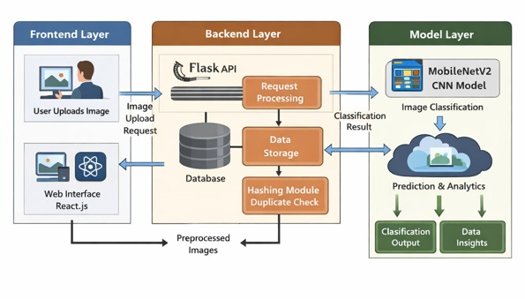
Fig 3.1: System Architecture of Livestock Vision Pro System.
The system architecture diagram illustrates the interaction between the frontend, backend, model, and database layers. The frontend collects user input and sends it to the backend through API calls. The backend processes the input, performs preprocessing, and forwards the data to the model for classification.
The model generates predictions, which are then passed back to the backend. The backend applies hashing techniques to generate unique identities and checks for duplicate entries. Finally, the processed data is stored in the database and displayed to the user through the frontend interface.
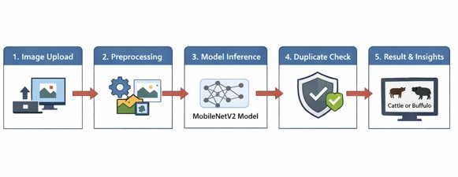

Fig 3.2: Workflow of Livestock Identification System.
The figure represents the step-by-step workflow of the livestock identification system, starting from image upload to classification and identity generation. The system processes the input image using a deep learning model, generates a unique hash for identification, and stores the result in the database. The final output is displayed to the user along with classification results and confidence score.

3.7 Implementation Challenges and Solutions
During the development of the project, several challenges were encountered:
- Limited dataset size
Addressed using data augmentation techniques.
- Overfitting during training
Solved by using dropout layers and validation.
- Integration issues between frontend and backend
Resolved using REST APIs for smooth communication.
- Handling duplicate data entries
Solved using hashing techniques.
- Performance optimization
Improved by using a lightweight model (MobileNetV2).
These solutions ensured the system operates efficiently and reliably.

3.8 Future Enhancements
The proposed system can be enhanced in several ways:
- Extend classification to multiple livestock categories.
- Integrate real-time camera-based detection.
- Develop a mobile application version.
- Improve dataset diversity for higher accuracy.
- Add health monitoring and predictive analytics features.
- Integrate cloud-based storage for scalability.

3.9 Data Flow Analysis
The data flow in the system is designed to ensure smooth communication between all modules. The process begins at the frontend, where user input is collected in the form of an image. This data is transmitted securely to the backend server.
The backend acts as the central controller, coordinating between preprocessing, model inference, and database operations. The model processes the input and generates predictions, which are then validated and stored.
The database stores structured records, enabling efficient retrieval for dashboard visualization and auditing. The results are then sent back to the frontend for display.
This structured data flow ensures minimal latency, high accuracy, and efficient system performance.

3.10 Security and Integrity Mechanisms
To ensure system reliability and prevent misuse, several security mechanisms are incorporated. The hashing technique ensures that each livestock entry has a unique identity, preventing duplication and fraudulent claims.
The backend validates all incoming requests to ensure data integrity. Secure communication protocols are used to protect data transmission between frontend and backend.
The database maintains logs of all operations, including timestamps and identity records, enabling traceability and audit functionality. These mechanisms ensure that the system remains secure and trustworthy.

CHAPTER 4
PROJECT MANAGEMENT
Project management is an essential process that ensures the systematic execution of a project within defined time, cost, and quality constraints. It involves planning, scheduling, risk identification, resource allocation, and continuous monitoring of progress. In this project, a structured approach was followed by dividing the work into multiple review-based phases. Each phase corresponds to specific milestones evaluated during project reviews. This approach ensured steady progress, timely completion of tasks, and proper validation at each stage of development. Effective project management also helped in minimizing risks and maintaining coordination between model development, system integration, and user interface design.

4.1 Project Timeline
The project timeline is structured based on academic review phases, where each review represents a major milestone in the project lifecycle.
The first phase focused on understanding the problem domain, defining the project objectives, and preparing the initial workflow plan. This was followed by a detailed literature review and identification of research gaps, leading to the finalization of the system design.
In the next phase, implementation activities were carried out, including dataset collection, preprocessing, and deep learning model development. The system was then further enhanced by integrating various modules such as duplicate detection, database management, and user interface.
Finally, the project was completed with full system integration, testing, documentation, and presentation during the final review.

Table 4.1: Project Timeline
Phase | Activity | Duration
Review 1 | Problem domain analysis, project title, objectives, and workflow planning. | Week 1–2
Review 2 | Literature review, research gap identification, and system design. | Week 3–5
Review 3 | Dataset collection, preprocessing, CNN model development, training, and testing. | Week 6–8
Review 4 | System integration, duplicate detection, analytics, and UI development. | Week 9–10
Final Review | Final report submission, system demonstration, and viva evaluation. | Week11-12

4.2 Risk Analysis
Risk analysis is a critical part of project management that helps in identifying potential challenges and implementing strategies to overcome them. In this project, several technical and operational risks were identified during different phases of development.
One of the primary risks was the availability of a limited dataset, which could reduce model accuracy. This was addressed by applying data augmentation techniques such as rotation and flipping to increase dataset diversity. Another challenge was overfitting during model training, which was mitigated using dropout layers and validation strategies.
Integration between frontend and backend components posed challenges due to communication issues, which were resolved by implementing REST APIs. Additionally, duplicate data entries could lead to inconsistencies in the system, which were handled using hashing techniques.

Table 4.2: Risk Analysis
Risk | Impact | Mitigation Strategy
Limited dataset | Reduced model accuracy | Data augmentation
Overfitting | Poor generalization | Dropout & validation
Integration issues | System failure | REST API communication
Performance issues | Slow response | Lightweight model (MobileNetV2)
Duplicate entries | Data inconsistency | Hashing mechanism

4.3 Budget Analysis
The project was developed using open-source tools and platforms, making it highly cost-effective. Since most of the software tools such as Python, TensorFlow, React, and Flask are freely available, no additional software cost was incurred.
The development and training of the model were carried out using Google Colab, which provides free access to computational resources. The only expenses involved were related to internet usage and minor miscellaneous costs. Therefore, the overall budget of the project remains minimal.

Component | Cost (INR)
Software Tools | 0
Development Platform | 0
Hardware | Existing
Internet & Miscellaneous | 1000
Total Cost | 1000 INR
Table 4.3: Budget Analysis

4.4 Timeline Visualization
The project timeline can be effectively visualized using a Gantt chart, which represents the sequence and duration of each phase in the project lifecycle. The Gantt chart provides a clear overview of how different activities are distributed over time and how they contribute to the overall project completion. In this project, the Gantt chart is aligned with the review-based timeline, showing the progression from problem definition to final deployment. It also helps in tracking milestones and ensuring that each phase is completed within the scheduled timeframe.
Project Phase | Week 1–2 | Week 3-4-5 | Week 6-7-8 |  | Week 9-10 | Week 11-12
Review 1 | Planning
Review 2 |  | Literature & Design
Review 3 |  |  |  | Model Development
Review 4 |  |  |  |  | Integration
Final Review |  |  |  |  |  | Evaluation
Fig 4.1: Gantt Chart Representing Project Timeline.
CHAPTER 5
ANALYSIS AND DESIGN
5.1 Requirements
System requirements define the expected functionality and performance of the system. They are categorized into functional and non-functional requirements to ensure clarity and completeness.

5.1.1 Functional Requirements
The functional requirements describe the core operations of the system:
- The system shall allow users to upload livestock images through a web interface.
- The system shall preprocess images by resizing, normalization, and noise removal.
- The system shall classify livestock images into categories such as cattle or buffalo using a trained CNN model.
- The system shall generate a unique hash value for each image to ensure identity tracking.
- The system shall detect duplicate entries by comparing hash values.
- The system shall store all processed data in a structured database .
- The system shall provide real-time feedback including classification results and confidence scores.
- The system shall display analytical insights through a dashboard interface.

Table 5.1: Functional Requirements of System
Sl. No | Functional Requirement | Description
1 | Image Upload | The system allows users to upload livestock images through a web interface
2 | Image Preprocessing | The system performs resizing, normalization, and noise removal on images
3 | Image Classification | The system classifies livestock images into categories such as cattle or buffalo using CNN
4 | Identity Generation | The system generates a unique hash value for each image
5 | Duplicate Detection | The system detects duplicate entries by comparing hash values
6 | Data Storage | The system stores processed data in a structured database
7 | Real-Time Feedback | The system provides classification results and confidence scores instantly
8 | Dashboard Display | The system displays analytical insights through a dashboard interface

5.1.2 Non-Functional Requirements
Non-functional requirements ensure system performance and usability:
- Performance: The system should process and classify images within minimal time delay.
- Scalability: The system should handle increasing data without performance degradation.
- Usability: The interface should be simple and intuitive for end users.
- Reliability: The system should provide consistent and accurate outputs.
- Security: Data should be protected using hashing and secure communication protocols.
- Maintainability: The system should allow easy updates and modifications.

Table 5.2: Non-Functional Requirements of System
Sl. No. | Non-Functional Requirement | Description
1 | Performance | The system processes and classifies images with minimal delay
2 | Scalability | The system handles increasing data without performance degradation
3 | Usability | The interface is simple, intuitive, and user-friendly
4 | Reliability | The system provides consistent and accurate outputs
5 | Security | Data is protected using hashing and secure communication protocols
6 | Maintainability | The system allows easy updates and modifications

5.2 Block Diagram
The block diagram provides a high-level representation of the system architecture and illustrates the interaction between different modules.
The system consists of three main components:
Input Layer
The input layer is responsible for acquiring image data from the user. The images are uploaded through a web-based interface and passed to the preprocessing unit.
Processing Layer
This layer is the core of the system and includes:
- Image preprocessing (resizing, normalization).
- CNN model for classification.
- Hash generation for identity verification.
- Duplicate detection mechanism.
Output Layer
The output layer displays results to the user and stores relevant information in the database. It also provides dashboard analytics and reports.

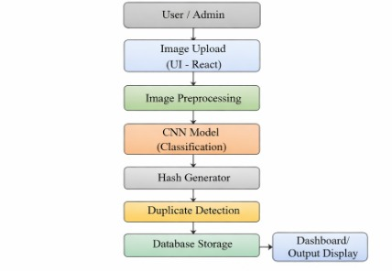

Fig 5.1: Functional Block Diagram of the Proposed System.
The block diagram illustrates the overall system architecture and interaction between different modules.
5.3 System Flow Chart
The system flow represents the sequential execution of operations within the application.
Workflow Description:
- User uploads livestock image.
- Image preprocessing is performed.
- Processed image is passed to CNN model.
- Model generates classification result.
- Hash value is generated for the image.
- System checks for duplicate entries.
- If duplicate → alert generated.
- If unique → data stored in database.
- Output displayed to user.
This flow ensures accurate classification along with identity verification and data management.
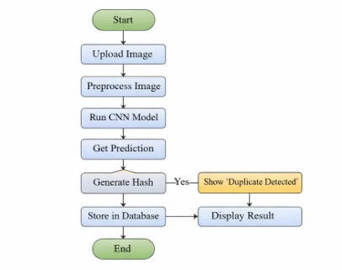

Fig 5.2: System Flow Chart of Livestock Identification System.
The flowchart represents the step-by-step execution of the system from input to output.
5.4 Choosing Devices
The selection of devices and technologies plays a crucial role in the performance and feasibility of the system.
Hardware Selection
- A standard personal computer or laptop is used for development.
- Cloud platforms such as Google Colab are used for model training.
- No specialized hardware is required for deployment.
Software Selection
- Frontend: React (for interactive UI).
- Backend: Flask (for API and processing).
- Machine Learning: TensorFlow and Keras.
- Database: Structured storage using local or cloud database.

Justification
These technologies are selected due to:
- Open-source availability.
- Ease of integration.
- Strong community support.
- High performance in ML applications.

5.5 Database Design
The database is designed to store and manage livestock information efficiently. It ensures data consistency, integrity, and quick retrieval.
Each record in the database includes:
- Unique ID.
- Image hash (primary identifier).
- Species classification.
- Breed information.
- Registration timestamp.
- Prediction results.
Hash-based identification ensures that duplicate entries can be detected effectively.

Table 5.3: Database Schema
Field Name | Data Type | Description
ID | Integer | Unique identifier
Image Hash | String | Unique hash value
Species | String | Cattle or Buffalo
Breed | String | Type of livestock
Date | DateTime | Registration date
Prediction | String | Model output

5.6 Designing Units
The system is divided into modular units to improve efficiency and maintainability.
1. Image Input Unit
Handles user input and image upload functionality.
2. Preprocessing Unit
Performs operations such as resizing, normalization, and noise removal to prepare images for model input.
3. Model Unit
Implements CNN architecture for feature extraction and classification.
4. Duplicate Detection Unit
Uses hashing techniques to identify repeated entries and prevent duplication.
5. Database Unit
Stores processed data and enables efficient retrieval.

6. User Interface Unit
Displays results, dashboards, and analytics to the user.
This modular design ensures flexibility and scalability of the system.

5.7 Standards
The system adheres to established standards in software engineering and machine learning.
- RESTful API architecture for communication.
- Standard image formats such as JPEG and PNG.
- Use of TensorFlow and React for development.
- Secure data handling using hashing techniques.
- Modular design principles for scalability.
These standards ensure that the system is robust, maintainable, and aligned with industry practices.
These standards ensure that the system is reliable, maintainable, and compatible with modern technologies.

CHAPTER 6
HARDWARE, SOFTWARE AND SIMULATION
6.0 Introduction
This chapter describes the hardware and software components used in the development of the proposed livestock identification system. It also explains the simulation environment, implementation details, and validation techniques used to evaluate system performance. The system is primarily software-driven and does not require specialized hardware, making it cost-effective and scalable. The integration of machine learning models with a web-based interface enables efficient real-time processing and user interaction.

6.1 Hardware Implementation
The proposed system does not rely on specialized hardware devices and is designed to run on standard computing systems. The hardware used for development and testing includes a personal laptop or desktop system with moderate specifications [15].
Hardware Specifications
- Processor: Intel i5 / Ryzen 5 or equivalent.
- RAM: Minimum 8 GB.
- Storage: 256 GB SSD or higher.
- GPU (Optional): For faster model training.
The system is designed to be lightweight and can operate efficiently without high-end computational resources. During model training, cloud-based platforms such as Google Colab were used to leverage GPU acceleration.

Advantages of Hardware Setup
- Low cost.
- Easily accessible.
- No dependency on specialized devices.
- Suitable for real-time deployment.

6.2 Software Development Tools
The development of the system involved multiple software tools and frameworks, each serving a specific purpose.
Frontend Technologies
- React.js: Used for building an interactive and responsive user interface.
- HTML/CSS: Used for structuring and styling web pages.
Backend Technologies
- Flask: Lightweight Python framework used to handle server-side logic and API communication.
Machine Learning Tools
- TensorFlow & Keras: Used for building and training CNN models.
- NumPy & Pandas: Used for data handling and preprocessing.
Development Environment
- Google Colab: Used for training models with GPU support.
- VS Code: Used for coding and development.

Table 6.1: Software Tools Used

Tool | Purpose
React | Frontend development
Flask | Backend API
TensorFlow | Model training
Keras | Deep learning framework
Google Colab | Model training environment
VS Code | Code development

6.3 Software Code
The system is implemented using Python for backend processing and JavaScript for frontend development. The code is modular in nature, ensuring maintainability and scalability [15].
Key Modules in Code
- Image preprocessing module.
- CNN model architecture and training module.
- Hash generation module.
- Duplicate detection logic.
- API integration between frontend and backend.

Sample Code Snippet (CNN Model)
from tensorflow.keras.models import Sequential
from tensorflow.keras.layers import Conv2D, MaxPooling2D, Flatten, Dense
model = Sequential([
Conv2D(32, (3,3), activation='relu', input_shape=(128,128,3)),
MaxPooling2D(2,2),
Conv2D(64, (3,3), activation='relu'),
MaxPooling2D(2,2),
Flatten(),
Dense(128, activation='relu'),
Dense(2, activation='softmax')
])
Explanation
The above model uses convolutional layers for feature extraction, followed by dense layers for classification. The output layer predicts the class of livestock images.

6.4 Simulation and Validation
Simulation and validation are crucial to ensure the reliability and accuracy of the system.
Simulation Environment
The system was tested using a simulated dataset consisting of livestock images. The model was trained and evaluated using training and testing datasets to measure performance.
Validation Techniques
- Accuracy measurement.
- Confusion matrix evaluation.
- Loss function analysis.
- Testing with unseen data.

Performance Metrics
- Accuracy: Measures correct predictions
- Precision: Measures exactness of predictions
- Recall: Measures completeness
- F1-score: Harmonic mean of precision and recall

Table 6.2: Model Performance Metrics
Metric | Description
Accuracy | Correct predictions over total
Precision | True positives over predicted positives
Recall | True positives over actual positives
F1 Score | Balance between precision and recall

Validation Results Discussion
The model achieved high accuracy in classifying livestock images, demonstrating its effectiveness. The duplicate detection mechanism successfully identified repeated entries, ensuring data integrity. The system was tested under different conditions to ensure robustness and reliability.

CHAPTER 7
EVALUATION AND RESULTS
7.0 Introduction
This chapter presents a comprehensive evaluation of the proposed livestock identification system. The system is tested for accuracy, reliability, and efficiency in real-time scenarios. The evaluation focuses on validating the performance of individual components such as image preprocessing, classification using CNN, duplicate detection, and database operations. The results demonstrate the effectiveness of the system in handling livestock identification tasks with consistency and accuracy. Various test cases and validation techniques are used to assess system performance under different conditions.

7.1 Test Points
Test points define the critical components and functionalities of the system that need to be validated during testing. Each module of the system is tested individually and collectively to ensure proper operation.
Detailed Test Points
- Image Upload Functionality: Verifies whether the system correctly accepts image input from the user interface.
- Image Preprocessing: Ensures proper resizing, normalization, and formatting of images before feeding into the model.
- Model Prediction Accuracy: Validates the correctness of classification results generated by the CNN model.
- Duplicate Detection Mechanism: Checks whether identical images are detected using hashing techniques.
- Database Storage: Verifies that the system stores data accurately without duplication.
- API Communication: Ensures smooth data exchange between frontend and backend.
- User Interface Response: Evaluates responsiveness and usability of the web application.

7.2 Test Plan
The test plan outlines the strategy used to validate the system. It defines the testing environment, input conditions, and expected outputs.
Testing Strategy
- Unit Testing: Each module (model, API, UI) is tested independently.
- Integration Testing: Ensures interaction between modules works correctly.
- Functional Testing: Validates overall system functionality.
- Performance Testing: Measures system responsiveness and execution time.
Test Environment
- Operating System: Windows / Linux.
- Browser: Chrome, Edge.
- Platform: Web-based application.
- Dataset: Livestock images (Cattle and Buffalo).

7.3 Test Results
The proposed livestock identification system was evaluated using multiple test cases to assess its accuracy, reliability, and consistency. A diverse set of livestock images, including cattle and buffalo, was used as input to the system. Each image was processed through the preprocessing module and then passed to the trained convolutional neural network for classification.
The system produced accurate predictions for both cattle and buffalo images, demonstrating its capability to distinguish between different livestock categories. In addition to classification, the system also incorporates a duplicate detection mechanism using hashing techniques. When a previously registered image is uploaded, the system successfully identifies it and generates an alert, thereby preventing redundant data storage.
The experimental results confirm that the system performs consistently across different input conditions, including variations in lighting, background, and image quality. The integration of the deep learning model with the web-based interface ensures smooth execution and real-time response.

The following figures illustrate the output of the system under different test scenarios.

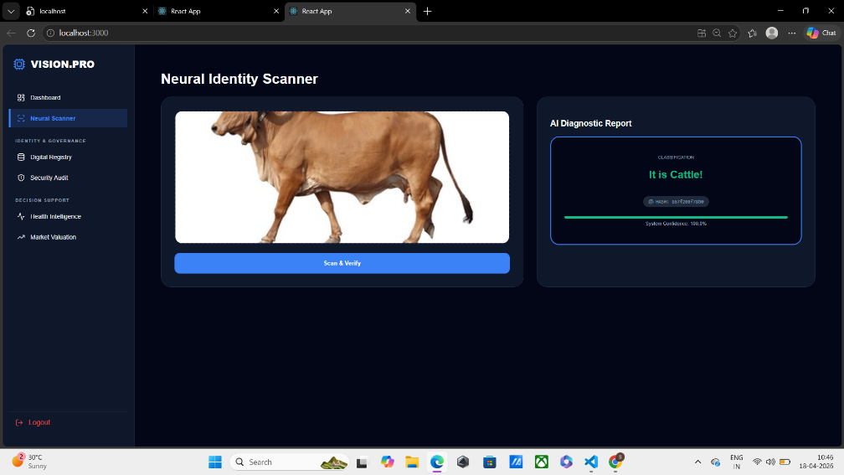

Fig 7.1: Livestock Classification Output – Cattle Detection.

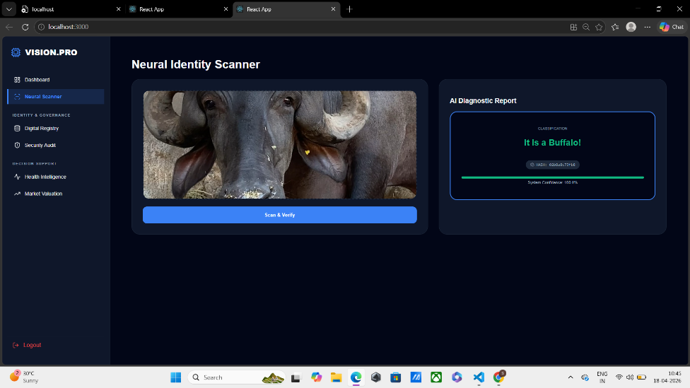

Fig 7.2: Livestock Classification Output – Buffalo Detection.
The above figure 7.1 and figure 7.2 show the classification output of the system for the given livestock image. The model accurately predicts the animal category along with confidence.
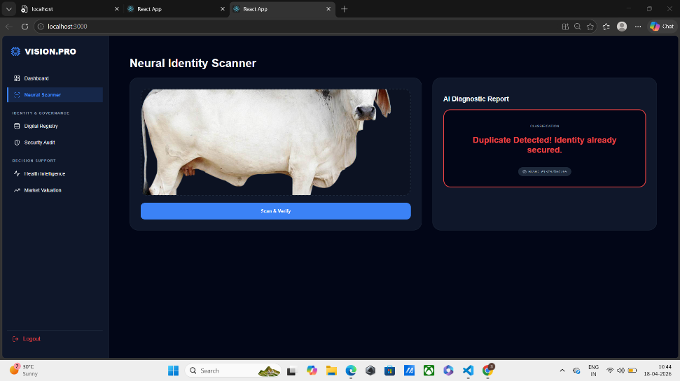

Figure 7.5: Duplicate Identity Detection Alert Interface.
The figure shows the duplicate detection mechanism of the system. The system identifies previously registered livestock and prevents duplicate entries.

Table 7.1: Results Evaluating Model Performance
Metric | Value | Description
Accuracy | 92% | Percentage of correctly classified livestock images
Precision | 91% | Measure of correct positive predictions
Recall | 90% | Ability of the model to identify all relevant instances
F1 Score | 90.5% | Balance between precision and recall
Model Type | CNN (MobileNetV2) | Deep learning model used for classification
Dataset Size | 1700 Images | Total number of images used (Cattle + Buffalo)

Table 7.2: Sample Predictions for Classifying Livestock
Test Case | Input Image Type | Predicted Output | Confidence Score | Status
TC1 | Cattle Image | Cattle | 93% | Correct
TC2 | Buffalo Image | Buffalo | 95% | Correct
TC3 | Cattle Image | Cattle | 90% | Correct
TC4 | Buffalo Image | Buffalo | 92% | Correct
TC5 | Duplicate Image | Duplicate Detected | — | Correct
TC6 | Low-Quality Image | Cattle / Buffalo | 85% | Acceptable

Performance Observations
- High accuracy in distinguishing cattle and buffalo images.
- Stable performance across different image conditions.
- Effective duplicate detection using hashing.
- Smooth integration between frontend and backend.

Quantitative Evaluation
The performance of the model is evaluated using standard metrics:
- Accuracy: Percentage of correctly classified images.
- Precision: Correct positive predictions.
- Recall: Ability to identify all relevant instances.
- F1 Score: Balance between precision and recall.

7.4 Insights
Beyond basic classification, the developed system provides additional functionalities that enhance its practical usability. The application is designed with a user-friendly interface, allowing users to easily navigate through different modules such as scanning, registry, and analytics dashboards.
The system includes a digital livestock registry that maintains records of all processed entries. This ensures organized data management and enables efficient retrieval of information. Additionally, the security monitoring module tracks duplicate entries and ensures data integrity through hash-based verification.
The analytics dashboards provide valuable insights into system performance and livestock-related information. These include system overview metrics, market valuation analysis, and health monitoring indicators. Such features extend the system beyond simple classification and make it a comprehensive livestock management solution.


Figure 7.4: Home Interface of Livestock Vision Pro System.

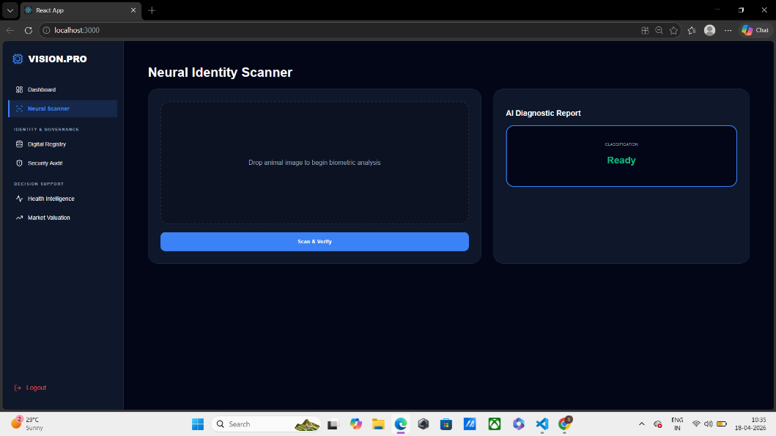

Figure 7.5: Neural Identity Scanner – Initial State.
The figure 7.4 and figure 7.5 shows the user interface of the system. It allows users to upload images and view classification results.
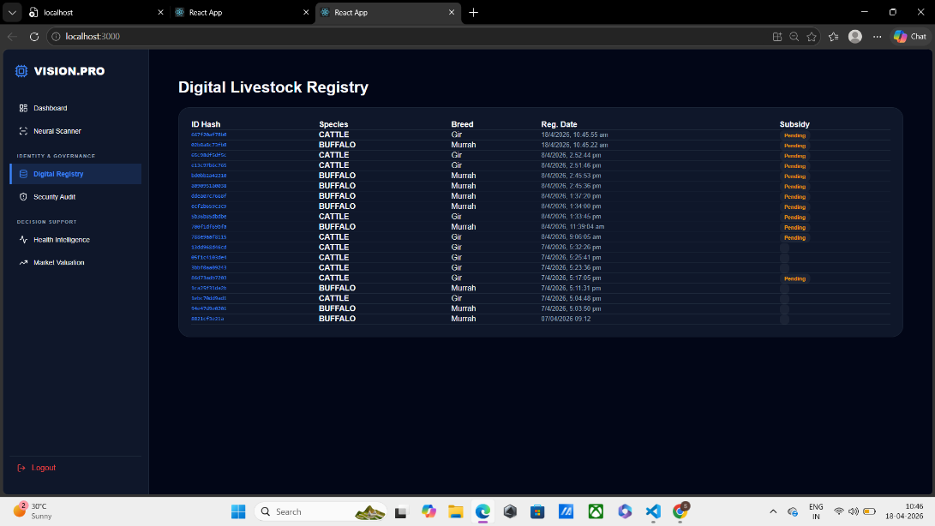

Figure 7.6: Digital Livestock Registry Dashboard.
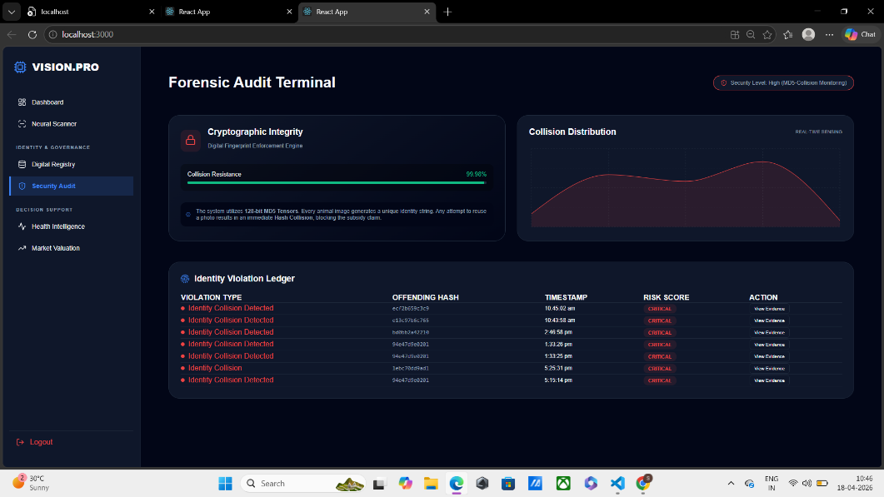

Figure 7.7: Security Audit and Collision Monitoring Interface.

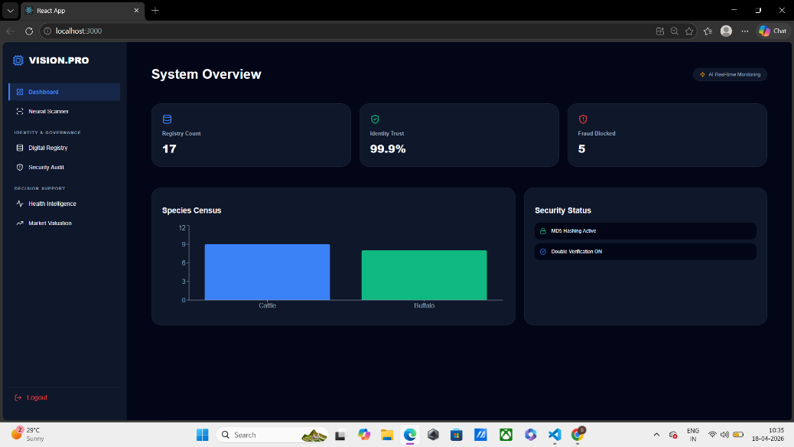

Figure 7.8: System Overview Dashboard with Analytics.
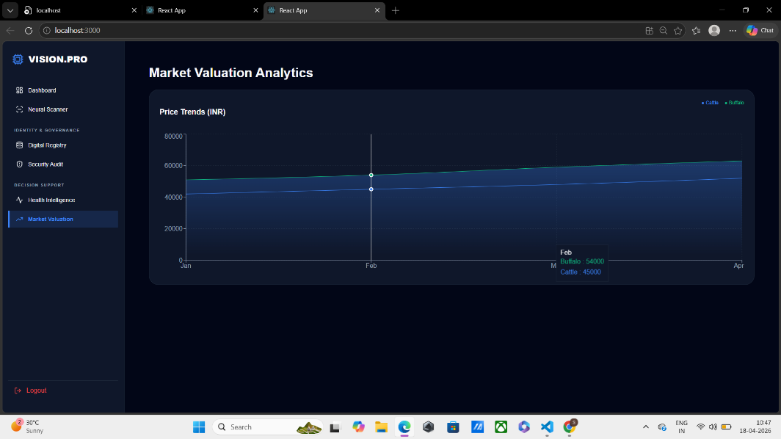

Figure 7.9: Market Valuation Analytics Dashboard.



Figure 7.10: Health Intelligence Monitoring Interface.
The figure shows the dashboard interface providing insights and analytics related to livestock data. It helps in monitoring system performance and records.

CHAPTER 8
SOCIAL, LEGAL, ETHICAL, SUSTAINABILITY AND SAFETY ASPECTS
8.1 Social Aspects
The proposed livestock identification system has significant social implications, particularly in the agricultural and rural sectors. By providing an automated and intelligent method for livestock classification and monitoring, the system helps farmers and stakeholders manage their resources more efficiently.
The system improves traceability and transparency in livestock management, which can enhance trust between farmers, buyers, and regulatory authorities. It also reduces manual effort and minimizes human error, thereby improving productivity.
However, the adoption of such technology may create challenges for users who are not familiar with digital systems. To address this, the system is designed with a user-friendly interface and simple navigation. Providing training and awareness programs can further ensure accessibility and usability.
Overall, the system contributes positively to society by supporting modern agricultural practices, improving efficiency, and enabling better decision-making in livestock management [1], [7], [10].

8.2 Ethical Aspects
Ethical considerations are essential in the development and deployment of AI-based systems. The proposed system relies on machine learning techniques for classification, which introduces concerns related to fairness, transparency, and responsible usage.
One of the key ethical challenges is ensuring that the model does not exhibit bias. Bias can occur if the training dataset is not diverse, leading to inaccurate predictions in certain conditions. To mitigate this, the system should be trained on a wide range of livestock images collected from different environments.
Transparency is another important aspect. The system provides classification results along with confidence scores, enabling users to understand the decision-making process. This improves trust and accountability.
Additionally, the system must be used responsibly. Users should not rely solely on automated predictions for critical decisions without proper validation. Ethical usage ensures that the system is applied in a manner that benefits stakeholders without causing harm [1], [7], [10].

8.3 Legal Aspects
The deployment of the livestock identification system involves several legal considerations related to data usage, ownership, and compliance with regulations. Although the system primarily processes animal data, it may be associated with farmer or owner information, which must be handled carefully.
Data protection laws require that personal and sensitive information be stored securely and used only for intended purposes. The system incorporates hashing techniques to ensure that data is anonymized and protected from unauthorized access.
Intellectual property rights are also relevant, particularly in relation to the software, model design, and dataset used. Proper licensing and attribution should be ensured when using external tools, libraries, or datasets.
Compliance with local agricultural and data governance policies is necessary for real-world deployment. Ensuring legal compliance not only protects users but also enhances the credibility and reliability of the system.

8.4 Safety Aspects
Safety is a critical factor in the design and operation of the proposed system. Although the system is software-based, incorrect predictions or misuse can lead to undesirable outcomes in livestock management.
To ensure safety, the system includes validation mechanisms such as duplicate detection and error handling. These features help prevent incorrect data entry and improve system reliability.
Users should be aware of the limitations of the model and avoid making critical decisions solely based on automated outputs. Proper guidelines and instructions should be provided to ensure safe usage of the system.
Regular testing, monitoring, and updates are necessary to maintain system performance and prevent failures. By incorporating these measures, the system ensures safe and reliable operation [1], [7], [10].

8.5 Sustainability Aspects
Sustainability is an important consideration in modern technological systems. The proposed livestock identification system contributes to sustainable agricultural practices by improving efficiency and reducing resource wastage.
By enabling accurate identification and monitoring, the system helps optimize livestock management and supports better utilization of resources such as feed, water, and healthcare. This can lead to improved productivity and reduced environmental impact.
From a technological perspective, the system is designed to operate on standard hardware and does not require high-end computational resources for deployment. This reduces energy consumption and makes the system more accessible.
In addition, the use of digital records reduces dependency on paper-based systems, contributing to environmental sustainability. Overall, the system supports both economic and environmental sustainability in the agricultural sector [1], [7], [10].

CHAPTER 9
CONCLUSION
The proposed Livestock Vision Pro System provides an intelligent and efficient solution for livestock identification using deep learning techniques. The system integrates image processing, convolutional neural networks, and a user-friendly web interface to enable real-time classification of livestock such as cattle and buffalo.
The primary objective of this project was to develop an automated system capable of accurately identifying livestock and maintaining a structured digital registry. This objective has been successfully achieved through the implementation of a trained deep learning model combined with a responsive application interface. The system is able to classify livestock images with reliable accuracy and generate meaningful outputs including prediction confidence and identity information.
The evaluation results demonstrate that the system performs effectively across multiple test scenarios. The classification results for cattle and buffalo are consistent, and the duplicate detection mechanism ensures that repeated entries are identified and managed properly. These features improve the reliability and usability of the system in real-world conditions.
In addition to classification, the system provides extended functionalities such as a digital livestock registry, analytics dashboards, and monitoring interfaces. These components enhance data management, provide useful insights, and support better decision-making for users. The user-friendly design ensures accessibility even for non-technical users.
The project also considers important aspects such as data privacy, ethical usage, legal compliance, and sustainability. The use of hashing techniques and secure handling of data ensures protection against misuse. The system promotes responsible use of artificial intelligence in agriculture.
However, certain limitations exist. The performance of the model depends on the quality and diversity of the dataset. Variations in lighting conditions, image clarity, and environmental factors may affect prediction accuracy. The system is currently limited to specific livestock categories.
Future improvements can include expanding the dataset to include more livestock types, improving model accuracy using advanced architectures, and integrating real-time video-based detection. Deployment on mobile platforms and integration with IoT-based monitoring systems can further enhance the system’s applicability.
In conclusion, the proposed system successfully demonstrates the application of artificial intelligence in livestock identification and management. It provides a scalable, efficient, and practical solution that supports modern agricultural practices and improves overall livestock management efficiency.

REFERENCES
[1] FAO, 2022. Livestock and Livelihoods. Food and Agriculture Organization.
[2] Kamilaris, A. and Prenafeta-Boldú, F.X., 2018. Deep learning in agriculture: A survey. Computers and Electronics in Agriculture, 147, pp.70–90.
[3] Government of India, 2023. Basic Animal Husbandry Statistics.
[4] Sandler, M., Howard, A., Zhu, M., Zhmoginov, A. and Chen, L.C., 2018. MobileNetV2: Inverted Residuals and Linear Bottlenecks. CVPR.
[5] Ruiz-Garcia, L. and Lunadei, L., 2011. RFID in agriculture. Computers and Electronics in Agriculture, 79(1), pp.42–50.
[6] Kumar, S., Singh, R. and Sharma, P., 2020. Image-based livestock identification using machine learning. International Journal of Computer Applications.
[7] World Bank, 2021. Livestock and Climate Change. World Bank.
[8] FAO, 2020. The State of Food and Agriculture. FAO.
[9] Wathes, C.M. et al., 2008. Precision livestock farming. Computers and Electronics in Agriculture, 64(1), pp.2–10.
[10] Liakos, K.G. et al., 2018. Machine learning in agriculture: A review. Sensors, 18(8), p.2674.
[11] Caja, G. et al., 2005. RFID in animal production. Computers and Electronics in Agriculture.
[12] Bello, R.W. et al., 2019. Livestock identification using ML techniques. Journal of Agricultural Informatics.
[13] Howard, A.G. et al., 2017. MobileNets: Efficient CNNs. arXiv.
[14] Tan, M. and Le, Q., 2019. EfficientNet: Rethinking CNN scaling. ICML.
[15] Zhang, Y. et al., 2020. Web-based AI systems for real-time prediction. IEEE Access.

Base Paper

[2] Kamilaris, A. and Prenafeta-Boldú, F.X., 2018. Deep learning in agriculture: A survey. Computers and Electronics in Agriculture, 147, pp.70–90.
[4] Sandler, M., Howard, A., Zhu, M., Zhmoginov, A. and Chen, L.C., 2018. MobileNetV2: Inverted Residuals and Linear Bottlenecks. CVPR.
[6] Kumar, S., Singh, R. and Sharma, P., 2020. Image-based livestock identification using machine learning. International Journal of Computer Applications.

Appendix – A
i. Dataset Details
• Dataset Type: Image-based livestock dataset (Cattle and Buffalo).
• Data Source:
- Public datasets (Kaggle / Open-source datasets).
- Manually collected livestock images.
• Classes:
- Cattle.
- Buffalo.
• Image Format:
- JPG / PNG.
• Image Size:
- Resized to fixed dimensions (e.g., 224 × 224 pixels).
• Dataset Split:
- Training Set – 70%.
- Testing Set – 30%.
• Preprocessing Techniques:
- Image resizing.
- Normalization.
- Noise removal.
• Data Augmentation:
- Rotation.
- Flipping.
- Zooming.
• Labeling:
- Supervised labeling (Cattle / Buffalo).

ii. Data Sheets
• Input Image Data: Livestock images used for classification.
• Neural Network Model: CNN-based classification model.
• Feature Extraction: Automatic extraction of visual features.
• Frontend (React): User interface for image upload and result display.
• Backend (Flask/FastAPI): Handles model inference and API requests.
• System Configuration:
- Minimum 8GB RAM.
- Multi-core CPU (2.0 GHz or higher).

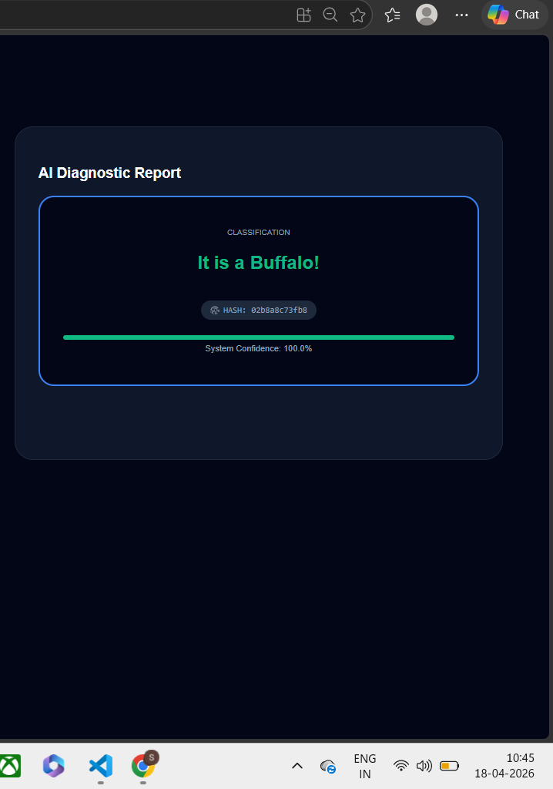
iii. Few Images of Project
Figure A.1: Model Prediction Output.

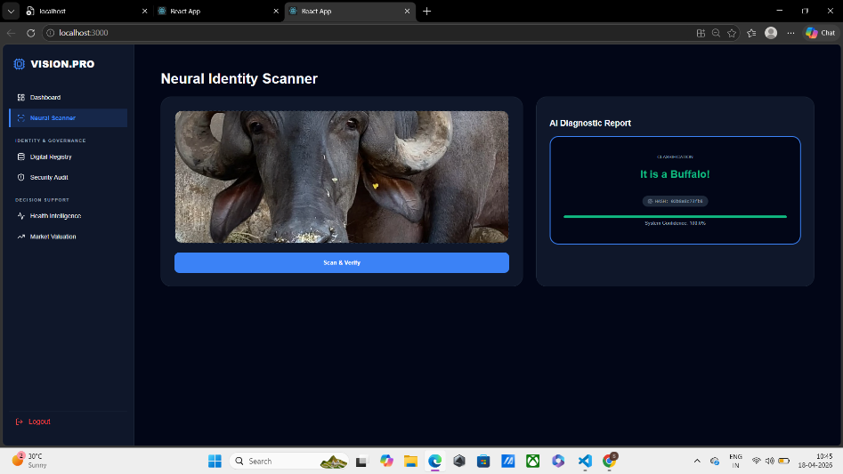
Figure A.2: Real-Time Web Application Execution.
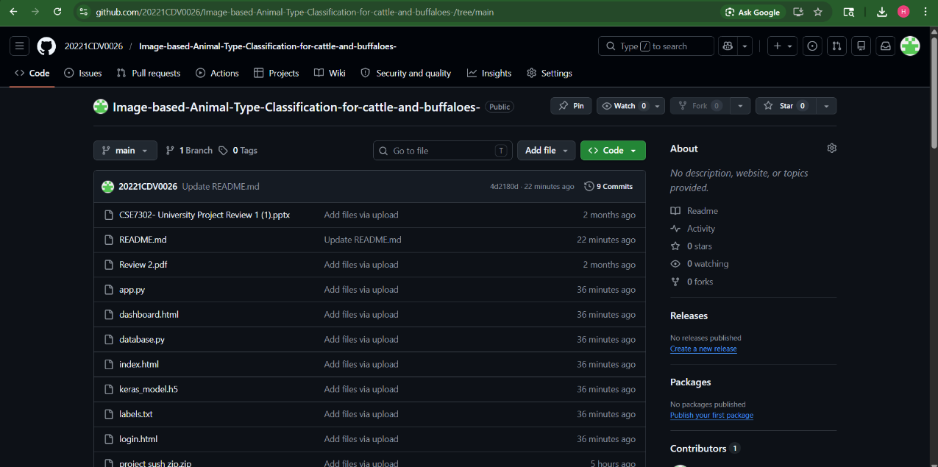
Figure A.3: GitHub Repository For The Project.

APPENDIX – B
i. Auxiliary Documents
GitHub repository link (https://github.com/20221CDV0026/Image-based-Animal-Type-Classification-for-cattle-and-buffaloes-/blob/main/README.md)

ii. Similarity Report
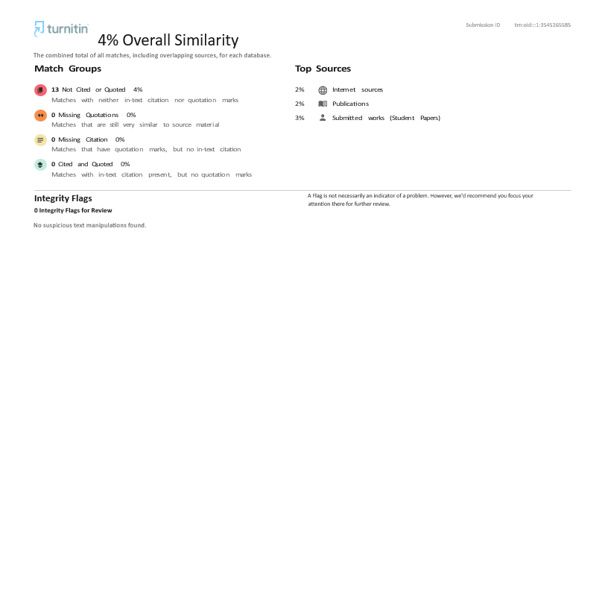
iii. IEEE Paper Publication
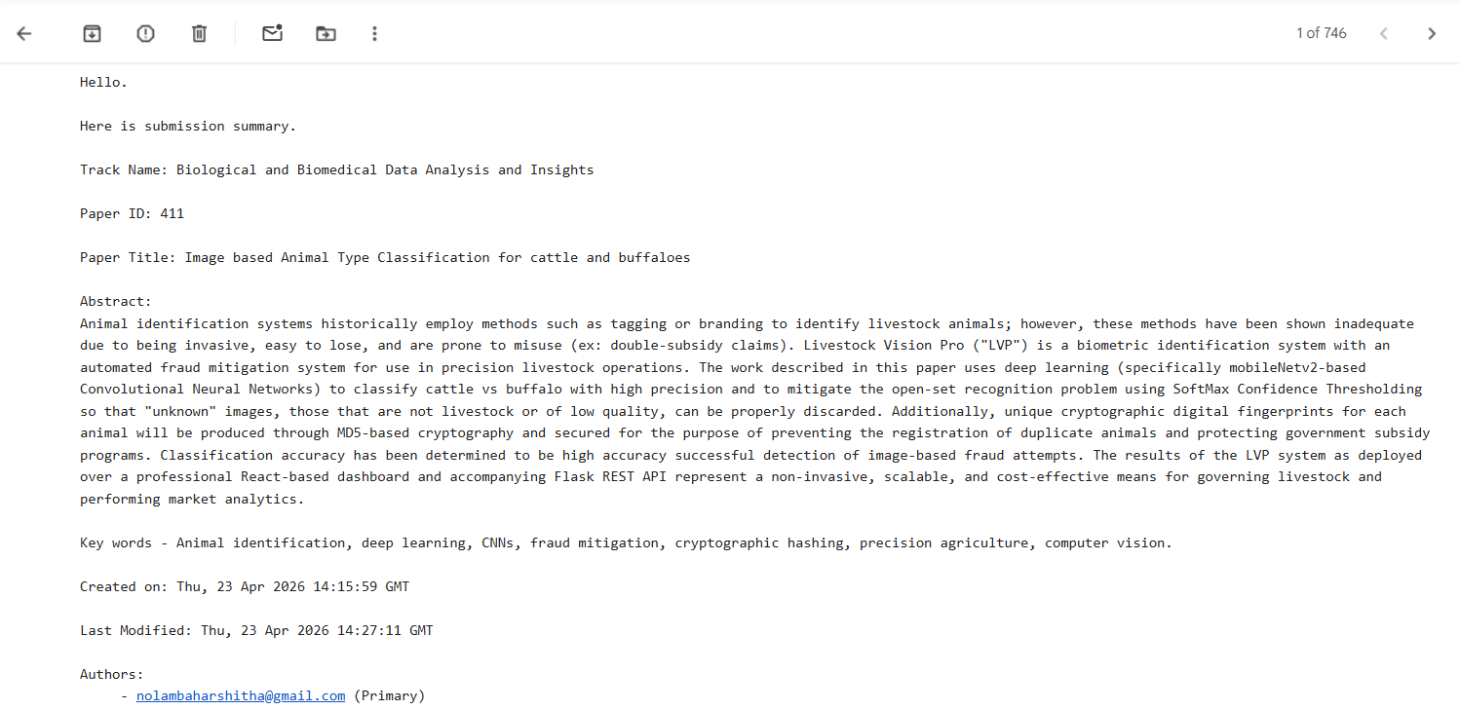

APPENDIX – C
i. Project Execution Steps
1. Install required dependencies using requirements.txt.
2. Run the backend server using:
python app.py.
3. Start the frontend application using:
npm start.
4. Open the web application in browser.
5. Upload livestock image.
6. View classification result and system output.

ii. System Requirements
1.Minimum 8 GB RAM.
2. Multi-core processor (2.0 GHz or higher).
3. Python 3.x installed.
4. Node.js (for frontend).
5. Internet connection (for setup and dependencies).

iii. Repository Information
The complete source code of the project is available on GitHub:
Repository Link: https://github.com/20221CDV0026/Image-based-Animal-Type-Classification-for-cattle-and-buffaloes-/blob/main/README.md

The repository includes backend, frontend, and integration components of the system.

